Conversation Café

Text for programme
If you are interested in learning more about the latest research methods and findings from your peers then come to the Conversation Cafés. Download the abstract to read about the research then join the author for a conversation. When the bell sounds, move to the next table to talk to another author!

Briefing for those attending
The Conversation Café format has been selected to enable abstract authors to gain as much exposure and peer feedback as possible and for IPCRG colleagues to learn from and build relationships with their peers. It is based on an approach developed by David Gurteen who describes it as “a conversational method in which small groups of people come together to have open, creative conversations on a topic of mutual interest, surface their collective knowledge, share ideas, and gain a deeper understanding of the issues involved……it also helps connect people, improve interpersonal relationships, break down organizational silos, and improve trust and engagement…..The real outcomes are what people take away in their heads and the relationships they develop.”

What happens?
Getting started
If you are an author, arrive on time at the conference room. We will hand you a print out of your abstract, but make sure you have access to the digital version of your abstract on your smartphone or laptop. Then sit at one of the tables.

If you are a delegate, arrive on time at the conference room. Use your smartphone or pc to download the abstracts that are being discussed during the session. The author will also have a hard copy of the abstract. We have 5 sessions, all in English and each with a different theme.
If you are a moderator, arrive on time at the conference room. Welcome everyone to the session and ensure the delegates spread out at all the tables. If for any reason there is a table with an author and without a delegate, suggest the author joins another author and do also join in! Check everyone knows what the abstracts are and how to access these using the online programme. Use these notes to help explain the process if anyone asks.
Do a timecheck – there should be 10-12 minutes for each conversation if delegates are to get to talk to all the authors.

Ring the bell to get things started!

Begin the conversation
Authors and delegates, start your conversation! Delegate - you might ask the author to summarise their findings, or ask more about the method or rationale. It’s up to you. Author: you may want to test out the generalisability of your findings, or if you have created a research idea, get further feedback about the design or feasibility. See where the conversation goes - this is about dialogue rather than a formal presentation.
David Gurteen proposes these principles, which we think are good to share
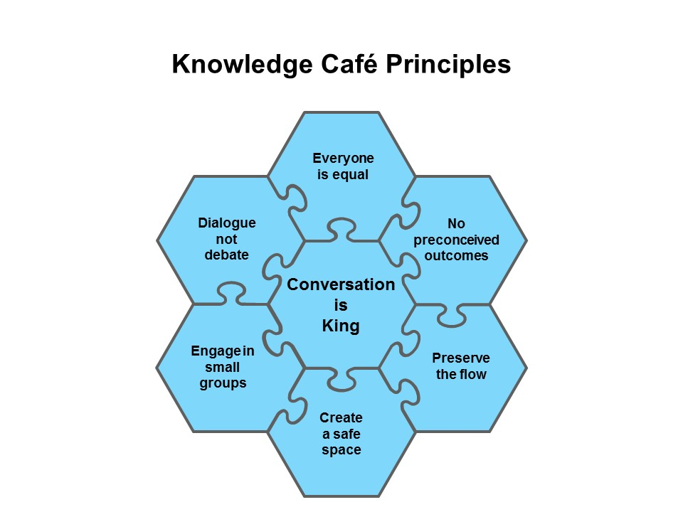
Moderators – when time is up, ring the bell. Authors stay where you are and delegates move to another table.

Repeat so that delegates have had a chance to talk to all the authors.
5-10 minutes before the end of the session, moderators, you may want to ask people for their reflections on both the process and what emerged from the conversations. However, it is not essential to do this, as we said at the beginning, “the real outcomes are what people take away in their heads and the relationships they develop.”

David Weinberger suggests the difference between talking and having a conversation in the Cluetrain Manifesto:
- To have a conversation, you have to be comfortable being human - acknowledging you don't have all the answers, being eager to learn from someone else and to build new ideas together.
- You can only have a conversation if you're not afraid of being wrong.
- Otherwise, you're not conversing, you're just declaiming, speechifying, or reading what's on the PowerPoints.
- To converse, you have to be willing to be wrong in front of another person.
- Conversations occur between equals.
- The time your boss's boss asked you at a meeting about your project's deadline was not a conversation.
- The time you sat with your boss for an hour in the Polynesian-themed bar while on a business trip and you really talked, got past the corporate bullshit, told each other the truth about the dangers ahead, and ended up talking about your kids - that maybe was a conversation.

Siân Williams

